In-Synch Implementation Notes - Updated June 23rd 2011

Setting up the Web server
The Clearnine web application requires a Linux server with the following components (typically referred to as LAMP)

Apache2 or better
- Module Rewrite is required http://httpd.apache.org/docs/2.2/mod/mod_rewrite.html

MySQL 5 or better
- 5.1.44+ recommended
- InnoDB Storage Engine is required for trigger and foreign key relationships used by the application
- PHPMyAdmin highly recommended for easy of database maintenance and configuration http://www.phpmyadmin.net/home_page/index.php
- A MySQL user with SELECT, INSERT, UPDATE and DELETE privileges needs to be created for the web applications to use as well as the In-Synch application http://dev.mysql.com/doc/refman/5.1/en/adding-users.html

PHP 5.2 or better
- PDO (PHP Data Objects) is required http://php.net/manual/en/book.pdo.php
- MCrypt module http://www.php.net/manual/en/mcrypt.installation.php

Other required components
- SSH Access
- FTP Access - ensure that multiple concurrent sessions are supported and that and “file list” limitations are removed or increased to 10,000
- Access to SMTP mail service for sending notifications
- SSL Certificate required for sites that collect credit card info and/or have login functionality
- At least one dedicated IP address if SSL is required

Setting up the Workstation for In-Synch
A secure communication link is recommended to encrypt data that is synchronized between the MAS 90/200 server and the web server database. The following configurations are done on the workstation where In-Synch will run:

The MySQL ODBC
InSynch uses the MySQL ODBC driver to communicate with the database on the web server
- http://dev.mysql.com/downloads/connector/odbc/

Bitvise Tunnelier
For secure communications we use Bitvise Tunnelier
- http://www.bitvise.com/tunnelier.
- A client to server SSH tunnel is configured to route MySQL connections to the web server over an encrypted SSH tunnel.
- MySQL port is 3306
- Tunnelier should be configured to automatically run at login time.

System DSN
A System DSN needs to be created in ODBC Administration in the Windows Control Panel
- Use localhost as the server - the SSH tunnel will redirect this connection to the server.
- Ensure that auto-reconnect is selected

WinSCP
WinSCP is used to synchronize images and other non-database files with the webserver
- http://winscp.net/eng/index.php
- Used to automatically synchronize images to the web server
- FTP (unencrypted) is fine
Sample scripts for Tunnelier and WinSCP can be provided.

Entering Data in MAS 90/200
When entering data in MAS 90 it is important to avoid using special characters in the key fields that are used on the web site. These specifically include the Category ID and the Item Number, as these are used as components of links. These fields should consist of letters, numbers, dashes and underscores only with no spaces, for example CATEGORY_ID_3 is OK, CATEGORY-ID-3 is preferred. CATEGORY ID 3 or CATEGORY-ID-#3 should not be used.

Getting Your Items Ready for In-Synch
Getting inventory items ready for In-Synch is very straightforward. Determine which items will appear on the website and:
- Make sure item images are the appropriate type for the web; JPEG, GIF or PNG images, JPEG and PNG are preferred.
- Make sure the images are of an appropriate size. While this will vary with the site, 400-500 pixels by 400-500 pixels is a good target for dimensions. File size should be as small as possible, under 30KB if possible.
- Make sure the image file name contains only letters, numbers, - and _ characters with no spaces.
- Image file names are case sensitive on the web server. Even though an image name in MAS 90 such as image.jpg will work if the file name is actually IMAGE.JPG, the website will not be able to match the images.
- Make sure the descriptions are appropriate for web customers. In-Synch has a separate Web description that may be used - see below
- Make sure your system calculated the correct prices automatically - the website will calculate the prices the same way sakes order entry does.
- Pre-plan and work with your partner, Clearnine or ROI Consulting to determine what, if any, UDFs may need to be added to the Inventory Item file with Customizer.

User Defined Fields
The following are the standard and optional User Defined Fields (UDFs) that should be created in MAS 90. This is a list of the basic UDFs - any number of UDFs in any synchronized table may be created to meet most requirements.

CI Item (standard fields, see below for fields required for the document attachments and additional images):
- Metadata_title -- 64 characters. Optionally used by the web application to provide for specific, targeted metadata for each item
- Metadata_description -- 64 characters. Optionally used by the web application to provide for specific, targeted metadata for each item
- Metadata_keywords -- 64 characters. Optionally used by the web application to provide for specific, targeted metadata for each item
- Item_web_title -- 50 characters. Optionally create a longer item title / short description field for use on the web site
- Item_web_long_description -- 1,000 or more characters. Optionally create a separate or additional long description for the item for use on the web site. This field may contain HTML Markup

CI Item - Document Attachments and Additional Images add-on):
- Document_type_# -- (five fields, #=1-5) 3 characters, condifure as a drop box with supported types: PDF, DOC, TXT, ZIP, etc. . Optionally used by the web application to provide for specific, targeted metadata for each item
- Document_description_# -- (five fields, #=1-5) 30 to 50 (50 max) or more characters.
- Document_name_# -- (five fields, #=1-5) 30 characters. The file name of the document - follow web standards, no spaces or special characters, case sensitive.
- Image_# -- 30 characters. Image file name. Follow web standards, no spaces or special characters, case sensitive.

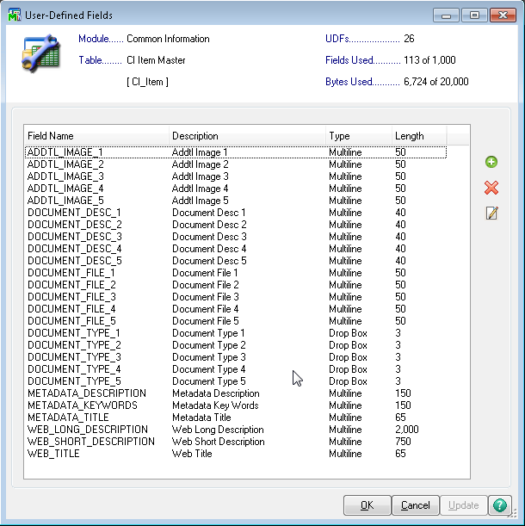

AR Customer Master:
- Creditcard_required_for_web -- Y/N field, generally a checkbox. In some cases you will want to specify that a customer must pay by creditcard regardless of their terms. This is for existing customers only - new customer credit card required is a web site configuration.

SO Sales Order Header:
- Web_order -- check box indication if the order originated from the web site

SO Shipping Rate Header
- Show_on_website -- checkbox that determines if the selected shipping method is available as a selection on the website.

Categorizing Your Items
In-Synch provides the capability to activate and categorize your items, but first you should determine an appropriate category structure. In-Synch and ClearnineCart support deep nesting of categories within categories. Any single category can have up to 7 direct parents, and items can appear in any number of categories. In general the steps are:
- Determine your 'top level" categories. It is usual that the top-level categories do not contain inventory items, but contain only categories, but they can contain items if needed. Top-level categories are identified in category maintenance.
- Determine the category structure and define the categories for the system, and specify what their parent categories are. All categories other than top-level categories must have a parent if the category is to be accessible on the web site.
- Enter the categories in the system using Category Maintenance on the In Synch Setup menu. You should give the categories a short and long description, and assign a representative image. Images for categories follow the same rules as images for items. The path for Item Images is ../MAS90/Images/XXX/ (XXX is the 3-character company code) Category images should be stored in ../MAS90/Images/XXX/Category/
- After you have defined all the categories and reviewed the structure, you can then activate and assign items to the categories using Item Activation on the Setup menu. This is where you select the items that will be synchronized to the website and assign them to categories. You may also opt to define the item descriptions for the web here rather than in inventory maintenance, but you will need to decide if you want to define the descriptions in Item Activation OR Inventory Maintenance.

Import Templates for Item Categorization
InSynch Category Maintenance and Item Activation support importing Categories, Category / Item relationships and Items to activate on the web site:

Category.csv
Column | Description
CategoryID | Up to 63 characters, no spaces or special characters other than “-“ and “_”
CategoryDescription | Short description, used in links
Active | Y / N
Type | B = Business-to-Business, C=Business-to-Consumer, D=both. Currently not used, set to D
IsTop | Is this a top-level category? Y / N
Template | Determines how items are listed within the category  L = list without images  D=detail with images
ImageFile | The filename for the category image. Remember that the web server is case sensitive to the filename entered here must exactly match the actual file name
ImageWidth | System calculated, leave blank
ImageHeight | System calculated, leave blank
Thumbnail fields | Not currently used
Parent Category ID fields | The Category IDs of the categories direct parents

CategoryItem.csv
Column | Description
CategoryID | Up to 63 characters, no spaces or special characters other than “-“ and “_”
ItemID | The Inventory Item Number. Ensure that Item Numbers in MAS 90 do not contain spaces or special characters other than “-“ and “_”

ItemActivation.csv
Column | Description
ItemID | The Inventory Item Number. Ensure that Item Numbers in MAS 90 do not contain spaces or special characters other than “-“ and “_”
Deescription | Not currently used

Setting Up Users
In general users set themselves up on the web and In-Synch creates the appropriate records in MAS 90, but for business to business and during the initial setup it is likely that you have existing customers that you want to give access to the web site. For the initial setup, users are set up using User Code Maintenance on the Setup menu in In Synch. The user code is the e-mail address of the user and the other fields are filled in, and the user is assigned to a customer record. In-Synch will synchronize this information to the website.
Note that editing the user in User Code Maintenance will overwrite what is on the website, so care must be taken. This can also be used as a mechanism to reset user passwords, and users can be disabled from within MAS 90 as well.

